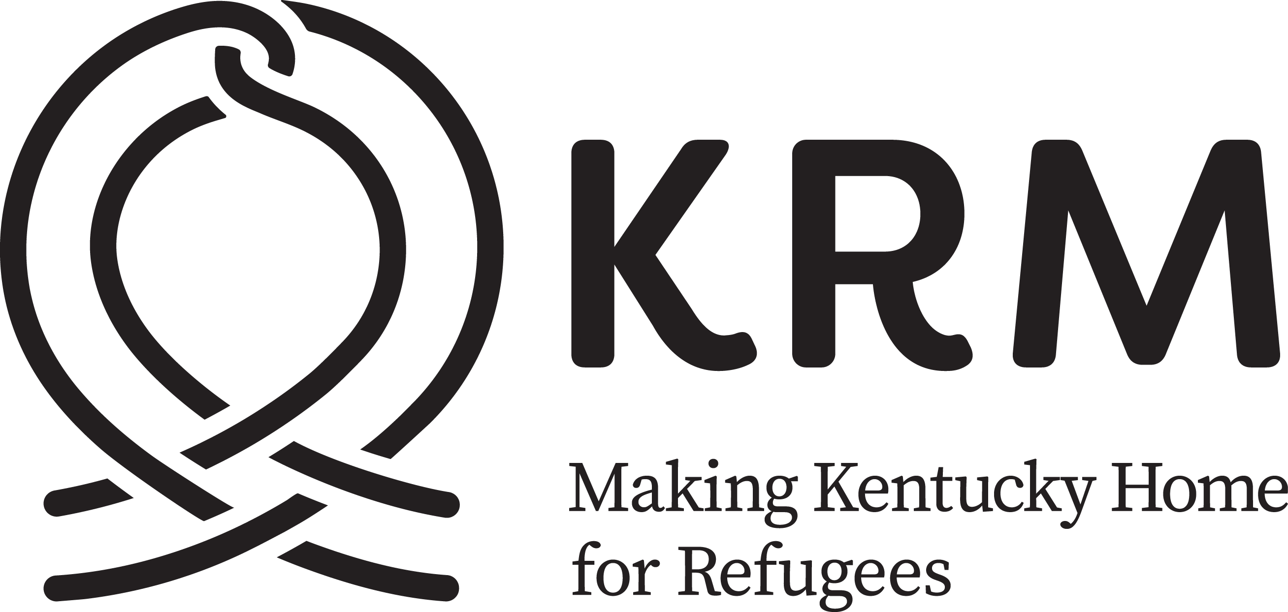

KRM Lexington Intern Opportunities

Interns must commit to a minimum of 8 hours per week, for a minimum duration of 6 weeks, or a minimum total of 80 hours. Internships may be limited to one program area or they may span multiple program areas depending on the intern’s interests/availability and the agency needs. Interns must be outgoing and have the ability to work independently. Language skills are preferred but not required.

To apply, interns must submit a completed Intern Application, Resume, and Background Check prior to interviewing for the position. Application documents are available online at KRM’s Careers and Internships page on kyrm.org. Contact the Volunteer Coordinator, Marlee Mirre, at (859) 226-5661 or mmirre@krmlex.org with any questions.

Communications Intern
Days/Times: Flexible hours during the week 8am-4pm
Description:
This individual will help to generate content for media and social media platforms. She/he will assist with developing local media contacts as well as assisting with managing and growing KRM’s mailing list. For this position, individuals must be willing to attend special events and assist with coverage (write-ups, photography), as well as attendance to events. It is also important for interns to research applicable events in the area. It is preferred but not required that intern has experience with WordPress and prior knowledge of the refugee resettlement process/populations.

Curriculum Development Intern
Days/Times: Flexible hours during the week 8am-4pm
Description:
The Curriculum Development intern will assist KRM staff in writing and developing curriculum for programs hosted at KRM. These programs include a Family Life Skills program and Job Readiness Assistance program. Intern will also assist KRM staff in writing ACT curriculum for KRM clients. Intern must have experience in curriculum development and must be a graduate level student.

ESL & Cultural Orientation Intern
Days/Times: M-F 8:30am-12:30pm
Description:
The ESL intern will assist our teachers in providing English language instruction to students at varying levels of language ability. He or she will help prepare and contribute ideas for materials and activities for classes and work to keep the classroom environment organized and inviting to English language learners. Most importantly, the intern will be present during classes to allow for more one-on-one and small group interaction with students, especially those at the very beginning levels of reading, writing, and speaking. During these interactions, the intern will help assess the abilities of each learner, considering their strengths and needs according to their previous educational experiences and the languages they currently use. Previous teaching experience, especially at the pre-reading level, is very helpful. The intern will also assist with logistics of Friday morning Cultural Orientation classes, including cultural adaptation and identifying challenges for the future. He or she must help with administering CO assessments on an as-needed basis (~ 15 min/client, can be scheduled during the week). The intern will also be responsible for assisting to edit existing PowerPoint presentations and developing new topic presentations. This individual may asked to perform other tasks which include anything from contacting and introducing speakers to scheduling upcoming classes. Interest in languages, patience, and joy in seeing each individual progress and succeed are essential.

Immigration Intern
Days/Times: Monday 8am-4pm
Description:
Immigration Intern will assist staff attorney and legal caseworker with administrative duties such as scanning, copying, filing, and letter writing. Immigration Intern will also be able to observe client interviews and the completion of immigration applications for permanent residency, citizenship, family reunification, and other forms of humanitarian relief. Immigration Intern may also assist with outreach about our immigration services. Immigration Intern may also be asked conduct legal research and writing on immigration law topics as well as other duties as assigned.

Mental Health and Extended Case Management Intern
Days/Times: Flexible hours during the week 8am-4pm
Description:
The Mental Health and Extended Case Management intern will work with the Case Manage to provide early assessment and referral for definitive evaluation and care for KRM clients prospectively needing mental health care. Identify and build a network of culturally competent mental health service providers and facilitate refugee access to this network. The intern will analyze insurance coverage, cost of care, interpreter services and other issues affecting refugee access to mainstream mental health services and develop a plan maximize client access to affordable mental health treatment. Intern will help to educate refugee resettlement agency staff and clients on the availability of mental health treatment options and integrate a coordinated system for mental health referrals into KRM’s case management. Intern must be able to coordinate with the KOR State Refugee Health Coordinator to ensure that the provision of mental health services for refugees is integrated into the overall plan for provision of refugee health care. Intern will be responsible for educating local mental health service providers on the care needs and cultural, linguistic and experiential profiles of the different refugee populations. Intern must be able to advocate for refugee access to mental health services and partner with other members of the community in advocating for increased mental health services for low-income and immigrant residents of our community. Intern may be required to provide opportunities for therapeutic group activities for specific populations and genders. Intern will be asked to identify high needs clients during regularly scheduled “At Risk” meetings with caseworkers. Interns will meet with clients to assess their needs and barriers to long term self-sufficiency, develop a service plan, and provide more individualized and supported case management. This individual will need to be comfortable to make referrals for services including: mental health and medical conditions, domestic violence, substance abuse, legal issues, childcare and family adjustment issues, and social and cultural adjustment. Intern will be responsible for coordinating transportation and interpreters for case management assessments and outside referrals; follow up on all referrals. Intern will enroll clients in Client Track, and document all interactions with clients through case notes and research and identify new service providers and resources. Intern must be an MSW student.

